**Batch: A-3 Roll No.: 16010122104**

**Experiment No. 8**

**Grade: AA / AB / BB / BC / CC / CD /DD**

**Signature of the Staff In-charge with date**

|  |
| --- |
| **Title:** Apply neighbourhood processing techniques**:** low pass, high pass and median filtering in spatial domain on a digital image. |

**Objective:** To learn and understand the effects of filtering in spatial and frequency domain on images using Matlab.

**Expected Outcome of Experiment:**

|  |  |
| --- | --- |
| **CO** | **Outcome** |
| **CO4** | Design & implement algorithms for digital image enhancement, segmentation & restoration. |

**Books/ Journals/ Websites referred:**

1. http://www.mathworks.com/support/
2. www.math.mtu.edu/~msgocken/intro/intro.html.
3. R. C.Gonsales R.E.Woods, “Digital Image Processing”, Second edition, Pearson Education
4. S.Jayaraman, S Esakkirajan, T Veerakumar “Digital Image Processing “Mc Graw Hill.
5. S.Sridhar,”Digital Image processing”, oxford university press, 1st edition."

**Pre Lab/ Prior Concepts:**

**Filtering in Spatial Domain:**

**Low pass filtering** as the name suggests removes the high frequency content from the image. It is used to remove noise present in the image. Mask for the low pass filter is:

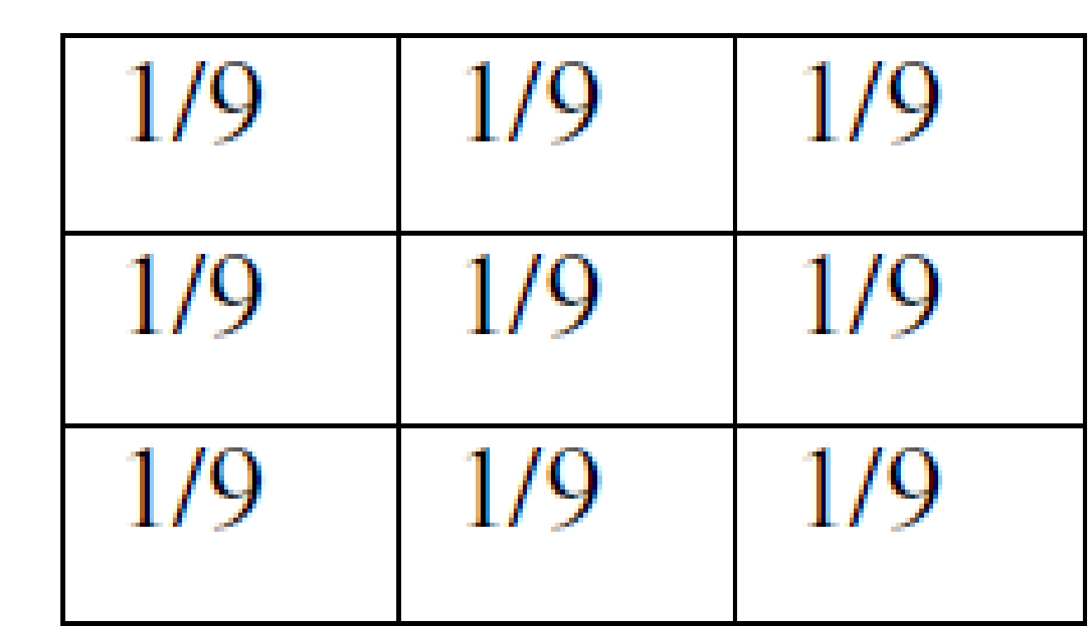

One important thing to note from the spatial response is that all the coefficients are positive. We could also use 5 x 5 or 7 x 7 mask as per our requirement. We place a 3 x 3 mask on the image. We start from the left hand top corner. We cannot work with the borders and hence are normally left as they are. We then multiply each component of the image with the corresponding value of the mask. Add these values to get the response. Replace the centre pixel of the o/p image with these responses. We now shift the mask towards the right till we reach the end of the line and then move it downwards.

**High pass filtering** as the name suggests removes the low frequency content from the image. It is used to highlight fine detail in an image or to enhance detail that has been blurred. Mask for the high pass filter is:

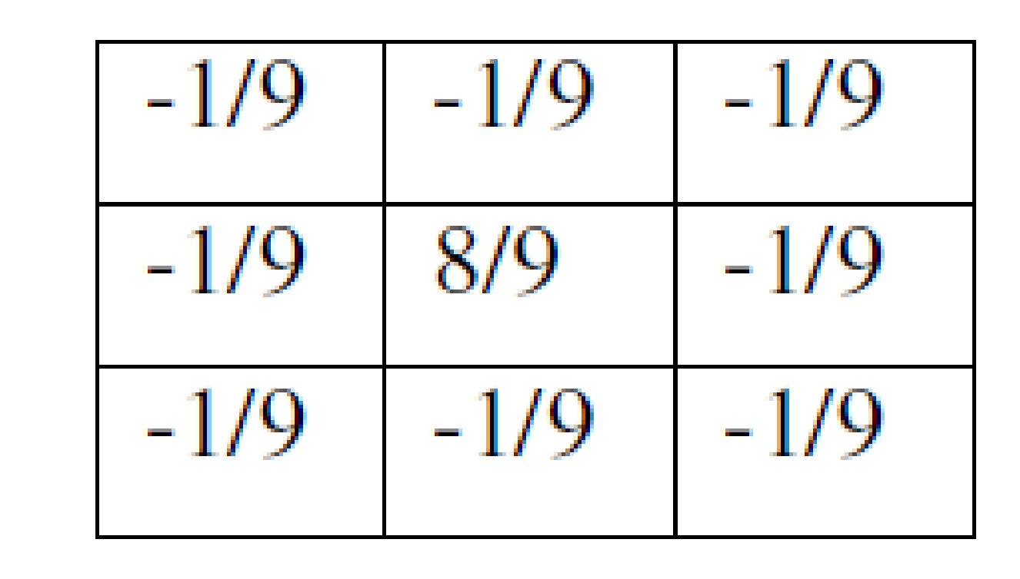

One important thing to note from the spatial response is that sum of all the coefficients is zero. We could also use 5 x 5 or 7 x 7 mask as per our requirement. We place a 3 x 3 mask on the image. We start from the left hand top corner. We cannot work with the borders and hence are normally left as they are. We then multiply each component of the image with the corresponding value of the mask. Add these values to get the response. Replace the centre pixel of the o/p image with these responses. We now shift the mask towards the right till we reach the end of the line and then move it downwards.

**Median filtering** is a signal processing technique developed by tukey that is useful for noise suppression in images. Here the input pixel is replaced by the median of the pixels contained in the window around the pixel. The median filter disregards extreme values and does not allow them to influence the selection of a pixel value which is truly representative of the neighbourhood.

**Implementation Details:**

**Write Algorithm and Matlab commands used:**

% MATLAB code for Low-pass, High-pass, and Median Filtering

% Read input image

img = imread('input_image.jpg');

% Convert to grayscale if image is RGB

if size(img,3) == 3

img_gray = rgb2gray(img);

else

img_gray = img;

end

% --- Low-Pass Filtering (Mean Filter) ---

lp_kernel = fspecial('average', [3 3]);

lowpass_img = imfilter(img_gray, lp_kernel, 'replicate');

% --- High-Pass Filtering (Edge Enhancement) ---

hp_kernel = [-1 -1 -1; -1 8 -1; -1 -1 -1];

highpass_img = imfilter(double(img_gray), hp_kernel, 'replicate');

highpass_img = uint8(mat2gray(highpass_img)*255);

% --- Median Filtering (Noise Reduction) ---

median_img = medfilt2(img_gray, [3 3]);

% --- Display Results ---

figure;

subplot(2,2,1);

imshow(img_gray);

title('Original Image');

subplot(2,2,2);

imshow(lowpass_img);

title('Low-pass Filtered Image');

subplot(2,2,3);

imshow(highpass_img);

title('High-pass Filtered Image');

subplot(2,2,4);

imshow(median_img);

title('Median Filtered Image');

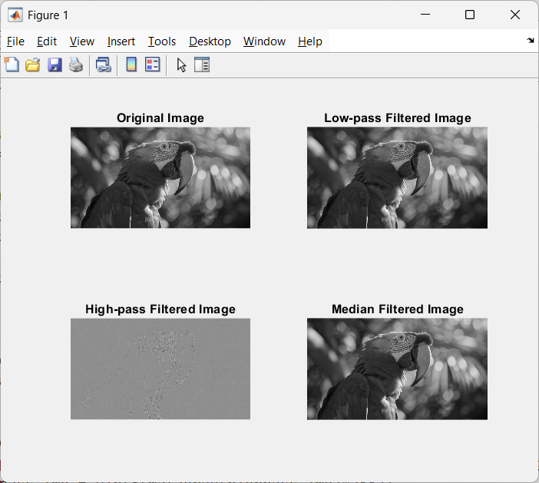

**Conclusion:-**

Applied neighbourhood processing techniques: low pass, high pass and median filtering in spatial domain on a digital image.

**Post Lab Descriptive Questions**

1. List & explain different types of noise associated with a digital signal.

**Ans:**

**Types of Noise in Digital Signals**

1. **Random Noise**
   * Characterized by intensity and color fluctuations above and below the actual image intensity.
   * Pattern changes even with identical exposure settings.
   * Influenced by ISO speed in digital cameras.
2. **Fixed Pattern Noise**
   * Consistent noise pattern that appears in the same location across multiple images.
3. **Banding Noise**
   * Appears as horizontal or vertical lines in images.
4. **Thermal Noise**
   * Generated by random thermal motion of charge carriers in electrical conductors.
   * Approximately white, with nearly equal power spectral density across frequencies.
5. **Shot Noise**
   * Results from random statistical fluctuations of electric current when charge carriers traverse a gap.
   * More prominent in vacuum tubes and some semiconductor devices.
6. **Flicker Noise (1/f Noise)**
   * Signal with a frequency spectrum that falls off steadily into higher frequencies.
   * Occurs in almost all electronic devices.
7. **Burst Noise (Popcorn Noise)**
   * Sudden step-like transitions between discrete voltage or current levels.
   * Can last for milliseconds to seconds.
8. **Transit-Time Noise**
   * Becomes significant at high frequencies (above VHF).
   * Occurs when electron transit time becomes comparable to the signal period.

2. Explain with the help of an example how filtering helps in enhancing the quality of an image.

**Ans:**

**Image Filtering Example**

Filtering helps enhance image quality by reducing noise and emphasizing certain features. Here's an example using low-pass filtering:

Consider a digital image affected by high-frequency noise, such as random fluctuations in pixel intensity. Applying a low-pass filter can significantly improve the image quality:

1. The low-pass filter acts as a smoothing operation, reducing the high-frequency components (noise) while preserving the low-frequency components (main image features).
2. Implementation:
   * Create a kernel (e.g., a 3x3 matrix with all elements 1/9).
   * Convolve this kernel with the image, replacing each pixel with the average of its neighborhood.
3. Result:
   * The filtered image will have reduced noise, appearing smoother and cleaner.
   * Fine details may be slightly blurred, but the overall image quality is enhanced by noise reduction.

This filtering process effectively removes or reduces random noise, improving the visual quality and making the image more suitable for further analysis or processing.